Use the Developer_ENU installer. Entering the product key unlocks the features available (Standard / Enterprise)

Agree to terms

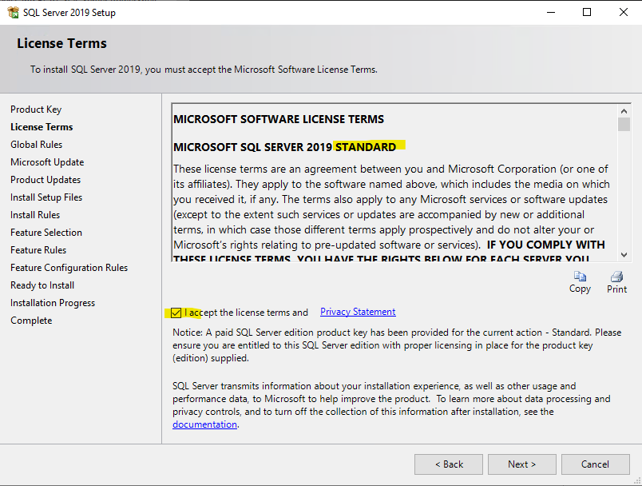

(Contrary to best practices) – don’t check for updates so as not to conflict with whatever processes IT currently has in place to patch. Eventually this should change once we’re responsible for patching SQL Server.

Our group has no control over or insight into firewall settings. Verify with someone (who?) that the following ports are open:

1433 TCP (default)

1434 UDP (named instances)

135 TCP (SSIS)

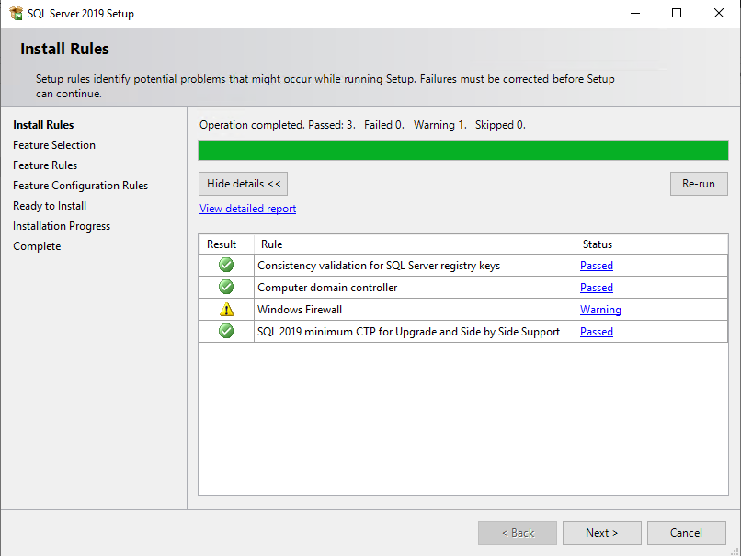

Barebones install should include SSIS. Refer to UCDB ETL for example justification.

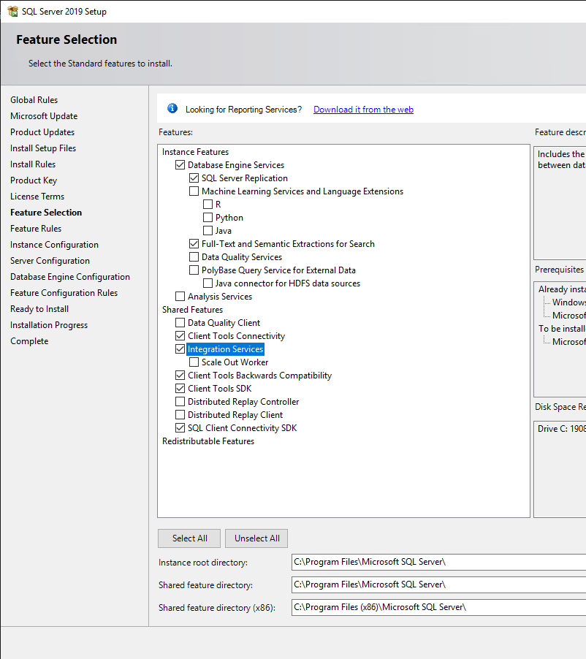

Install default instance before adding named instances to aid in detection / troubleshooting efforts:

The majority of the DBA group has limited insight into and influence over server provisioning at SierraSpace. The degree to which application owners request processor / core changes on servers as part of their proprietary troubleshooting efforts is unknown. Therefore, set MAXDOP to 0.

Leave adequate RAM for OS, as well as for whatever proprietary application level configurations on the DB Host are necessary.

Leave FILESTREAM disabled (but available) unless otherwise requested

Verify key attributes before installing (Server Collation, Directories, Administrative Access, etc.)

